

BCS 2023

ANNUAL CONFERENCE

5-7 JUNE 2023

MANCHESTER CENTRAL,

MANCHESTER

EXHIBITOR MANUAL

CONTENTS

[INTRODUCTION 3](#_Toc125546744)

[TIMETABLE 4](#_Toc125546745)

[DEADLINES AND FORMS 5](#_Toc125546746)

[A-Z GENERAL INFORMATION 6](#_Toc125546747)

[Audio Visual 6](#_Toc125546748)

[Badges and Passes 6](#_Toc125546749)

[Banners 7](#_Toc125546750)

[Carpet 7](#_Toc125546751)

[Cash Machine 7](#_Toc125546752)

[Catering 7](#_Toc125546753)

[Cleaning 8](#_Toc125546754)

[Cloakroom 8](#_Toc125546755)

[Contractors 8](#_Toc125546756)

[COVID-19 8](#_Toc125546757)

[Customs Clearance 8](#_Toc125546758)

[Delegate List 8](#_Toc125546759)

[Deliveries 8](#_Toc125546760)

[Electrical 9](#_Toc125546761)

[Exhibitor Editorials 9](#_Toc125546762)

[First Aid and Emergency Procedures 10](#_Toc125546763)

[Furniture 10](#_Toc125546764)

[Heart Advert Offer 10](#_Toc125546765)

[Health and Safety 10](#_Toc125546766)

[Internet and Wi-Fi 11](#_Toc125546767)

[Lifting and Shipping 11](#_Toc125546768)

[Lost Property 11](#_Toc125546769)

[Meeting Programme 11](#_Toc125546770)

[Networking Drinks Reception 12](#_Toc125546771)

[Printing and IT Support 12](#_Toc125546772)

[Parking 12](#_Toc125546773)

[Prayer Room 12](#_Toc125546774)

[Registration Opening Times 12](#_Toc125546775)

[Rigging 13](#_Toc125546776)

[Security 13](#_Toc125546777)

[Selling Products 13](#_Toc125546778)

[Shell Schemes 13](#_Toc125546779)

[Smoking 13](#_Toc125546780)

[Space Only 14](#_Toc125546781)

[Sponsorship Opportunities 14](#_Toc125546782)

[Storage 14](#_Toc125546783)

[Waste 14](#_Toc125546784)

[Water 14](#_Toc125546785)

[Welcome Pack 14](#_Toc125546786)

[Wheelchairs 14](#_Toc125546787)

[SHELL SCHEME INFORMATION 15](#_Toc125546788)

[Permitted 16](#_Toc125546789)

[Not Permitted 16](#_Toc125546790)

[A-Z RULES AND REGULATIONS 17](#_Toc125546791)

[Annoyance 17](#_Toc125546792)

[Balloons and Bottled/Compressed Gas 17](#_Toc125546793)

[Broadcast of Music 17](#_Toc125546794)

[Children and Animals 17](#_Toc125546795)

[Conduct of Exhibitors/Contractor 17](#_Toc125546796)

[Dilapidation Charges 18](#_Toc125546797)

[Environmental Policy 18](#_Toc125546798)

[Insurance 18](#_Toc125546799)

[Liability 18](#_Toc125546800)

[Meeting Blackout Periods 19](#_Toc125546801)

[Microphones/Audio Visual Equipment 19](#_Toc125546802)

[Publicity Material 19](#_Toc125546803)

[Soft Breakdown in the Education Zone of Education Hall 19](#_Toc125546804)

[Special Risks e.g., Smoke, Lasers, Inflatables, Medical Lasers, Strobes 19](#_Toc125546805)

[BUILD UP/BREAK DOWN RULES AND REGULATIONS 20](#_Toc125546806)

[Important Information Regarding Stand Approvals 20](#_Toc125546807)

[Space Only Exhibitors 21](#_Toc125546808)

[Welfare Arrangements 22](#_Toc125546809)

[Vehicles And Pedestrian Routes 22](#_Toc125546810)

[Build Information Space Only – Health and Safety 23](#_Toc125546811)

[Exhibitors Health and Safety Declaration and Exhibitor Risk Assessment Form 23](#_Toc125546812)

[EXHIBITION TERMS AND CONDITIONS 24](#_Toc125546813)

[KEY CONTACTS 28](#_Toc125546814)

[GETTING TO MANCHESTER 29](#_Toc125546815)

[DELIVERY ACCESS 30](#_Toc125546816)

INTRODUCTION

On behalf of the Programme Committee, we are delighted to present the British Cardiovascular Society Annual Conference 2023, which will be held at Manchester Central from 5-7 June 2023. We would like to thank you for taking this opportunity to exhibit.

The Annual Conference attracts over 2,200 delegates - consultant cardiologists, trainees and allied health professionals all with the aim of being educated and updated in the latest cardiology advances in clinical cardiology, pharma, devices and science.

As well as a full programme of informative lectures delivered by an international Faculty, the Exhibition Hall now hosts interactive learning opportunities throughout the duration of the conference. These learning opportunities include simulators and hot topics. Year on year we endeavour to improve the programme of educational activities and also introduce something ‘a bit different’ to keep your interest over the three days!

Please find within this Exhibitor Manual all of the relevant information that you will need prior to and during the conference. Please read this document and attached forms to ensure that you do not miss any key deadline dates or any other information which may be of importance to your planning and attendance at the meeting.

Should you require any further information, please do not hesitate to contact the BCS 2023 Conference team. We very much look forward to welcoming you to Manchester!

|  |  |
| --- | --- |
| W:\Photos & Images Library\Signatures\Executive (Board)\John_Greenwood.jpg | W:\Photos & Images Library\Signatures\Executive (Board)\Andre Ng.PNG |
| Professor John Greenwood | Professor André Ng |
| **President** | **Vice President, Education and Research** |

**BCS CONTACT DETAILS**

British Cardiovascular Society

9 Fitzroy Square

London

W1T 5HW

Phone: +44 (0)20 7383 3887

Email: [exhibition@bcs.com](mailto:exhibition@bcs.com)

Website: [www.britishcardiovascularsociety.org](https://www.britishcardiovascularsociety.org)

TIMETABLE

|  |  |  |  |  |
| --- | --- | --- | --- | --- |
|  | **DATE** | **DESCRIPTION** | **TIMES** | **DELIVERIES/COLLECTIONS** |
| Space only stands | Sat 3th June | Construction of Stands | 09:00 – 20:00 | Accepted between these hours |
| Sun 4th June | Complete Construction of Stands | 08:00 – 13:00 | Accepted between these hours |
| Mon 5th June | Dressing of Stands Only | 07:45 – 08:30 | No deliveries permitted |
|  | | | | |
| Shell scheme stands | Sun 4th June | Access to Shell Scheme Stands for Exhibitors | 14:00 – 20:00 | Accepted between these hours |
| Mon 5th June | Dressing of Stands Only | 07:45 – 08:30 | No deliveries permitted |
|  | | | | |
| Exhibition opening days | Mon 5th June | Hall Open  Exhibition Opens | 07:45 – 19.00  08.30 – 17:30 | No deliveries permitted |
| Tue 6th June | Hall Open  Exhibition Opens  Networking Reception | 07.45 – 18:30  08.00 – 19:30  From 17:30 | No deliveries permitted |
| Wed 7th June | Hall Open  Exhibition Opens | 07.45 – 23:00  08.00 – 16:00 | N/A |
|  | | | | |
| Stand breakdown | Wed 7th June | Removal of Exhibits and Stand Fittings | 16:00 – 22:00 | Accepted between these hours. A soft breakdown is from 16:00-17:00 only, where hi vis and appropriate footwear is not required, before full breakdown commences at 17:00 |

**IMPORTANT NOTE: PENALTY COSTS FOR LATE BUILD UP/BREAKDOWN**

If any exhibitor/contractor overruns the exhibition closing time during build-up on Saturday 3rd June 2023 and Sunday 4th June 2023 and have not vacated the Exhibition Hall an immediate penalty of £1,000 + VAT per hour will be imposed until 23:00. After 23:00 access will be denied, this is non-negotiable. Please be aware that any stand equipment/materials onsite will be charged as waste by the Venue incurring additional charges.

Breakdown will commence at the discretion of the Organisers and under no circumstances should breakdown start before an announcement has been made to ask all visitors to leave the hall. Soft breakdown will commence once all visitors have left the Exhibition Hall. If any exhibitor/contractor overruns the exhibition close time during breakdown on Wednesday 7th June 2023 and have not vacated the Exhibition Hall Loading Bay by 23:00, an immediate penalty of £5,000 + VAT will be imposed from 23:00 until 23:59. After 23:59 access will be denied, this is non-negotiable.

DEADLINES AND FORMS

|  |  |  |
| --- | --- | --- |
| **DEADLINE DATE** | **ITEM** | **RETURN TO** |
| ASAP | Sponsorship Opportunities | claire.cartwright@bcs.com |
| Fri 28th April | [Editorial Form](https://forms.office.com/Pages/ResponsePage.aspx?id=J5MM59zL-0KY_gNOYKDVf_83QyXshY5Ouz3bd57AG8RUOVU3RzFIMlZPMzI0TE1NM1BNVUIyVDJGQS4u) | BCS - [Follow](mailto:exhibition@bcs.com) Microsoft Forms link |
| Fri 28th April | Exhibitors Health & Safety Declaration & Exhibitor Stand Risk Assessment Form (shell and space) | carol@onsitex.co.uk |
| Fri 28th April | All ‘Space Only’ stand plan submissions to be submitted | carol@onsitex.co.uk |
| Fri 5th May | [Exhibitor/Contractor Name Badges Form](https://forms.office.com/Pages/ResponsePage.aspx?id=J5MM59zL-0KY_gNOYKDVf_83QyXshY5Ouz3bd57AG8RUMVEzTThSNVIzQllHTEVZRUFDVVQ4UlVBQi4u) | BCS - [Follow](mailto:exhibition@bcs.com) Microsoft Forms link |
| Tue 9th May | [Electrical Equipment](https://bcs2023.exhibitconnect.co.uk/%20) | Full Circle Ltd – order through online platform |
| Tue 9th May | [Shell Scheme Name Panel](https://bcs2023.exhibitconnect.co.uk/%20) | Full Circle Ltd – order through online platform |
| Tue 9th May | [Shell Scheme Accessories / Shell Scheme Accessories Plan](https://bcs2023.exhibitconnect.co.uk/%20) | Full Circle Ltd – order through online platform |
| Tue 9th May | [Floorcoverings](https://bcs2023.exhibitconnect.co.uk/%20) | Full Circle Ltd – order through online platform |
| Tue 9th May | Deliveries, Lifting, Storage | GES Logistics |
| Tue 9th May | Ordering Trollies for Deliveries | GES Logistics |
| Tue 9th May | [Furniture](https://dzinefurniture.com/browse-catalogue) | Dzine |
| Tue 9th May | Rigging | KRS |
| Tue 9th May | Water and Waste | Manchester Central |
| Tue 9th May | Audio Visual Equipment Hire | Sterling Event Group |
| Mon 22nd May | Catering | Manchester Central |
| Mon 22nd May | IT Services | Manchester Central |

A-Z GENERAL INFORMATION

Audio Visual

A full range of audio-visual equipment may be hired from our official contractor, **Sterling Event Group.**

Website: [www.manchestercentral.co.uk/online-ordering](https://www.manchestercentral.co.uk/online-ordering)

Phone: +44 (0)[161 436 4444](tel:+44%20(0)161%20436%204444)

Email: [info@sterlingeventgroup.co.uk](mailto:info@sterlingeventgroup.co.uk)

Please remember that sound must be kept to a reasonable level and that if you intend to play live or pre-recorded music you will need to obtain the relevant entertainment licence. Please refer to the A-Z Rules and Regulations section, Broadcasting of Music.

Badges and Passes

Please complete the relevant form in order to obtain your Exhibitor Passes, which are to be worn at all times throughout the conference.

Each exhibiting company will be issued with a number of **free, transferable full conference badges and/or exhibitor badges.** Please refer to allocation below:

**Option 1**

Stand - 8mx8m (64m2)  
4 x Conference Badges (company name only so transferable)

20 x Stand/Exhibition Badges

**Option 2**

Stand - 8mx4m (32m2) 3-open sided stand  
2 x Conference Badges (company name only so transferable)

10 x Stand/Exhibition Badges

**Option 3**

Stand - 4mx4m (16m2)  
1 x Conference Badge (company name only so transferable)

5 x Stand/Exhibition Badges

**Option 4**

Stand - 3mx3m (9m2)   
1 x Conference Badge (company name only so transferable)

3 x Stand/Exhibition Badges

**Charity stand**

Stand - 3mx2m (6m2)   
3 x Stand/Exhibition Badges

Banners

Banners are permitted within the exhibition subject to the Exhibition Organiser’s approval. Please submit any proposals for rigged banners above stands with the working drawings to carol@onsitex.co.uk. **Posters/Banners may not be displayed in any area other than above or on their exhibition stand/sponsored area. See Rigging section for further information.** If you request any drop-down banners hanging from the ceiling, please complete the relevant form.

**KRS Rigging**

**Phone: +44 (0)1253 894 688**

**Email:** [MCCC@knightrigging.co.uk](mailto:MCCC@knightrigging.co.uk)

**Website:** [www.knightrigging.co.uk](http://www.knightrigging.co.uk)

Carpet

The shell scheme stands will be carpeted with grey and the aisles will be black. If you wish to change your stand carpet for an alternative colour or finish, **please order through the online platform** or contact Full Circle. Full Circle will also organise the removal of your carpets.

**Full Circle Ltd**  
Phone: +44 (0)161 393 3949  
Email: [exhibitors@exhibitconnect.co.uk](mailto:exhibitors@exhibitconnect.co.uk)

Cash Machine

A cash machine is available on site. Please note that there is a charge with any cash withdrawal.

Catering

Please note that refreshments (teas & coffees) are provided for Exhibitors.

In order to comply with licensing regulations, any food, refreshments (including tea and coffee) or alcohol you wish to offer from your stand must be purchased from the official venue caterers. Additionally, there will be Coffee Areas located in the Education Hall for purchases of drinks and light refreshments. Please click the link below or contact Manchester Central Hospitality for more information.

To order online:

Click on this link: [www.manchestercentral.co.uk/online-ordering](https://www.manchestercentral.co.uk/online-ordering)

Click through to the Exhibitor Services

Select the ‘Sign Up’ button

Once you have signed up select your event from the list

You will then be asked to enter your stand number

Add your order to the basket and follow the checkout process (baskets can be saved to return to at a later date)

Manchester Central Hospitality

Phone: +44 (0)161 827 7656

Email: [catering@manchestercentral.co.uk](mailto:catering@manchestercentral.co.uk)

Cleaning

All stands within the exhibition will be cleaned nightly during the open period of the event, this includes vacuuming or mopping of stand floors (single storey only). Please note that this does not include cleaning of exhibits or other stand surfaces. If you require an enhanced service for your stand, please contact Natalie at Manchester Central with requirements for a bespoke quotation:

Manchester Central

Contact: Natalie Prew

Email: [n.prew@manchestercentral.co.uk](mailto:n.prew@manchestercentral.co.uk)

Cloakroom

The main cloakroom will be located in close proximity to Registration. Normal operating hours are 30 minutes before the event opens and 30 minutes after the event closes.

**Please note** Manchester Central will not accept any electrical items in the cloakroom.

Contractors

The BCS has a list of companies appointed as Official Contractors for the British Cardiovascular Society Annual Conference 2023. We encourage you to use the services of our official contractors as these have been vetted by the Organisers. A representative from each contractor will be available onsite during the build-up period. Refer to the relevant forms or Key Contacts section of the manual for full details.

COVID-19

The government has removed remaining domestic restrictions in England. There are still steps you can take to reduce the risk of catching and spreading COVID-19:

* Get vaccinated
* Let fresh air in if meeting indoors, or meet outside
* Consider wearing a face covering in crowded, enclosed spaces.

Customs Clearance

It is the exhibitor’s responsibility to carry out correct customs formalities for equipment/products arriving from abroad. The HM Revenue & Customs office requires 48 hours’ notice to process customs clearance. The Organisers will not be held responsible for any difficulties which may arise in connection with such formalities. Further information should be obtained direct from Revenue & Customs Helpline: 0300 322 9434.

Delegate List

Due to data protection reasons, we **will not** be providing a delegate list post-conference.

Deliveries

Please ensure deliveries are made only between the times stated in the table on page 4. Please note when booking a delivery that some couriers do not deliver on Sundays.

Manchester Central cannot accept deliveries before tenancy, or store items after tenancy. Manchester Central staff and BCS staff will not sign for any deliveries made.

**Please note** that Manchester Central has two delivery addresses depending on when deliveries are being made.

**Deliveries/ collections during build up and breakdown:**   
Manchester Central Convention Complex  
Albion Street   
Manchester   
M1 5JB   
  
**Small Deliveries during show open:**

Manchester Central Convention Complex  
Windmill Street

Manchester   
M2 3GX

Electrical

**Shell Scheme Stands**

All electrical installations must be done by the official contractor Full Circle Events & Exhibitions.

Full Circle Events & Exhibitions have now moved on to an online platform and orders can be placed for Electrics at: [https://bcs2023.exhibitconnect.co.uk/](https://bcs2023.exhibitconnect.co.uk/%20)

Each exhibitor will receive a unique username and password from Full Circle (via [exhibitors@exhibitconnect.co.uk](mailto:exhibitors@exhibitconnect.co.uk)) to be able to log onto the portal. Please also check your junk/spam folder. If you are experiencing any technical issues with this service or need help with your orders, please contact Full Circle on 0161 393 3949 or email them at [exhibitors@exhibitconnect.co.uk](mailto:exhibitors@exhibitconnect.co.uk). If you are using a Contractor, please ensure you pass on your login details to them.

**Please note** that extension leads must not be used on sockets over 500w. Cable reel systems should not be used unless fully extended due to the potential for overheating.

**To order your electrical requirements, please order through the online platform. For any assistance, please** contact:

**Full Circle Ltd**

Phone: +44 (0)161 393 3949  
Email: [exhibitors@exhibitconnect.co.uk](mailto:exhibitors@exhibitconnect.co.uk)

Exhibitor Editorials

As part of your stand booking you are entitled to have up to 50 words of free editorial included within the www.britishcardiovascularsociety.org website.

Please fill in the relevant form and send it back to [exhibition@bcs.com](mailto:exhibition@bcs.com)

First Aid and Emergency Procedures

Emergency procedures are included in this manual and will also be distributed to all exhibitors in the Welcome Pack before the event opens. Please ensure that all your stand personnel are aware of these procedures.

An equipped First Aid Point will be located near Registration. Assistance may also be obtained via any member of the security staff or the Organiser. Please DO NOT contact the ambulance service directly. A member of security staff will call if required. Any accidents that take place in the halls must be reported to both the Organiser’s Office and the First Aid Point.

Furniture

To order furniture for the event please visit: <https://dzinefurniture.com/browse-catalogue>

Contact: Kimberley Turvey

Email: [Kimberley@dzinefurniture.com](mailto:Kimberley@dzinefurniture.com)

Phone: +44 ([0)1299 824 100](tel:01299824100)

Heart Advert Offer

We are offering a discount of **25% from the rate card** for exhibitors if you book and provide copy before 24th April 2023. Make sure your product stands out, advertising space does fill up quickly.

Advertising in Heart in print and/or online can help raise your profile among key decision makers within cardiology. Heart is a leading cardiology title with a strong clinical and educational focus. Content covers the breadth of cardiovascular disease.

Call or email Sophie to book your campaign:

Contact: Sophie Fitzsimmons

Phone: +44 (0)20 3655 5612   
Email: [sfitzsimmons@bmj.com](mailto:sfitzsimmons@bmj.com)

Health and Safety

The official Health and Safety contractor is ONSITE Exhibition Services Limited. Health and Safety aspects of our event are very important and in this regard we require that the Health and Safety Risk Assessment and Declaration Form are completed by **ALL** exhibitors and returned to:

ONSITE Exhibition Services Limited

Contact: Carol MacInnes

Phone: +44 (0)7974 223 670

Email: [carol@onsitex.co.uk](mailto:carol@onsitex.co.uk)

Internet and Wi-Fi

Wi-Fi is free throughout Manchester Central.

Please click the link below or contact Manchester Central if you require a hard wired internet connection or premium WIFI

[www.manchestercentral.co.uk/online\_ordering](http://www.manchestercentral.co.uk/online_ordering)

Manchester Central  
Phone: +44 (0)161 827 7676  
Email: [EventsIT@manchestercentral.co.uk](mailto:EventsIT@manchestercentral.co.uk)

Lifting and Shipping

The official lifting and shipping contractor for the conference is **GES Logistics**. Please refer to the relevant form or contact them directly:

**GES Logistics**  
Contact: Joe Hodson  
Phone: +44 (0)121 782 4433  
Email: [event.logistics@ges.com](mailto:event.logistics@ges.com)

GES Logistics can provide the following services:

* Specialist customs clearance services for international exhibitors
* Safe warehouse storage for consignments both before and after the event
* A courier receiving service for consignments sent by other couriers to show site
* Delivery for consignments to and from the venue
* Unloading, reloading and positioning by forklift or crane on stand
* Empty case storage for the duration on the show
* Door to door services from your location to advance warehouse or direct to show site and return shipping after the event or onwards shipping to your next event.

**Please note** that when sending items via an independent courier asignature will be required for delivery, so a member of your staff must be present to do this (to ensure items are not lost or stolen).

All deliveries and collection must be labelled clearly, with exhibitors available to sign for the delivery/return and not left unattended on stand.

Lost Property

Lost property will be taken to the Security Control Room within the venue. If you have lost something or if you wish to hand in anything that you have found, please go to the Concierge Desk located at Manchester Central Foyer main concourse.

Meeting Programme

Please visit [www.britishcardiovascularsociety.org](https://www.britishcardiovascularsociety.org) for a copy of the latest Conference programme.

Networking Drinks Reception

A networking drinks reception will be held on Tuesday 6th June in the Education Hall from 17:30 and will be open to all.

Printing and IT Support

Manchester Central has a dedicated Business Centre located at the Concierge Desk in the Central Foyer. Whether you need printing, photocopying, document scanning, laminating, stationery, office supplies, IT support, fax facilities, florist services, toiletries or even a range of Manchester gifts, just speak to the Venue Concierge. They're there to help.

For additional requirements call +44 (0)161 827 7680, email [businesscentre@manchestercentral.co.uk](mailto:businesscentre@manchestercentral.co.uk) or simply drop by.

Parking

Manchester Central has a 24 hour NCP car park located directly below the building holding 720 cars, including 18 disabled parking bays. Lift, stairs and escalator access is available from the car park into Manchester Central.

For discounted parking for exhibitors, all drivers wishing to use the discount must have the NCP ParkPass app installed on their phones. Please use the code **MCEXHIB14** to receive a discount on the day. This discount is available to anyone working at or attending the event and gives a rate of £14 per day.

Manchester Central NCP

Lower Mosley Street

Manchester M2 3GX

Email: [ManchesterCentralVoucherapplication@ncp.co.uk](mailto:ManchesterCentralVoucherapplication@ncp.co.uk)

Prayer Room

A prayer room is available at the venue. Registration desk staff will provide directions to this room.

Registration Opening Times

Registration desks will be located at the entrance of the Exhibition Hall. The registration will be open during the following times:

Monday 5th June: 08:00 – 17:30

Tuesday 6th June: 08:00 – 17:30

Wednesday 7th June: 08:00 – 15:30

Rigging

If you wish to order rigging for this Event, please contact Knight Rigging Services.

**Please note** anycustom-built/bespoke structures constructed from non-modular materials, e.g., wooden structures and exhibits, are classed as “complex” and as such require structural sign off by a Structural Engineer.

Phone: +44 (0)1253 894 688  
Email: [MCCC@knightrigging.co.uk](mailto:MCCC@knightrigging.co.uk)

Website: [www.knightrigging.co.uk](https://knightrigging.co.uk/)

Security

The Organisers will take all reasonable security precautions during the build-up, open and breakdown periods. However, all exhibitors are advised that they should take steps to protect their property. Any precautions you take are in your best interest as neither the Organisers, Manchester Central or appointed contractors are responsible for any loss or damage to any goods at any time during the exhibition.

It is essential that you report any loss sustained from your stand to the Venue Security and/or Organisers Office immediately. Please follow these guidelines:

* Delegate one member of your stand personnel to be responsible for your company’s safety and security at the exhibition. Do not leave cash, handbags, mobile phones, valuables etc. in drawers, cupboards or on open exhibits on your stand. Do not leave wallets/purses in unattended clothing.
* Check all lockable desks and cupboards before leaving your stand.
* Please note that build-up and breakdown days are high risk periods - during these times any items/equipment left on unattended stands remain the responsibility of the exhibitor at all times.
* You are recommended to work in pairs so the stand is manned at all times.
* Any goods left on stands are at Exhibitors own risk. It is recommended adequate insurance is organised.

**Please note** there will be 100% bag search upon entry Monday 5th June - Wednesday 7th June.

Selling Products

Please inform Claire Cartwright at [exhibition@bcs.com](mailto:exhibition@bcs.com) if you are planning to sell any products at the BCS Conference as this has to be approved and authorised by the BCS Programme Committee.

Shell Schemes

**If you have booked an exhibition space with a Shell Scheme please complete the relevant forms** ASAP, and return to [exhibition@bcs.com](mailto:exhibition@bcs.com).

Smoking

Exhibitors should note that there is a no smoking policy throughout the Premises. Additionally, e-cigarettes/vaping are not permitted inside. There are designated smoking areas external to the Venue on the front forecourt.

Space Only

Construction of all space only stands MUST commence on Saturday 3rd June 2023. All exposed platform edges adjoining gangways must be rounded or splayed.

Sponsorship Opportunities

Should you be interested in any other sponsorship opportunities during the BCS 2023 Annual Conference, please refer to **the relevant form or contact** Claire Cartwright at [exhibition@bcs.com](mailto:exhibition@bcs.com).

Storage

There are no storage facilities available to Exhibitors within the exhibition area. If you require storage use then please contact our Lifting & Shipping contractor **GES Logistics** or refer to the relevant form.

**GES Logistics**  
Contact: Joe Hodson   
Phone: +44 (0)121 782 4433  
Email: [event.logistics@ges.com](mailto:event.logistics@ges.com)

Waste

Please note that any exhibitors or their contractors leaving excessive amounts of rubbish or materials behind at the end of the event are liable for any costs associated with their disposal. If you have any queries about rubbish removal, please contact Manchester Central.

Phone: +44 (0)161 827 8746

Email: [tempservices@manchestercentral.co.uk](mailto:tempservices@manchestercentral.co.uk)

Water

Please see the relevant form from Manchester Central for further details about supplying of water to your stand.

Phone: +44 (0)161 827 8746

Email: [tempservices@manchestercentral.co.uk](mailto:tempservices@manchestercentral.co.uk)

Welcome Pack

Exhibitors will receive a Welcome Pack which will include Organiser’s onsite contact details and a copy of the full Conference Programme. Please collect from the main Registration desks.

Wheelchairs

All entrances at Manchester Central are fully ramped and accessible for wheelchairs and there are some self-propelled wheelchairs available for use within the venue. To enquire, contact the First Aid department on +44 (0)161 834 2700 ext.2211. Bookings should be made in advance, as availability cannot be guaranteed otherwise.

SHELL SCHEME INFORMATION

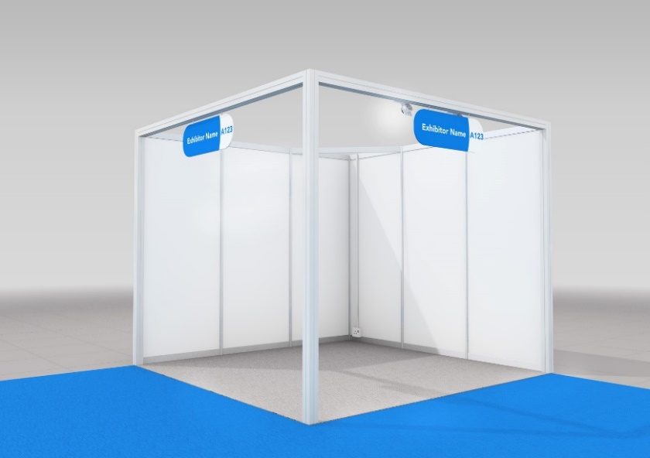

A visual example of a shell scheme stand

Your stand has been built using our stock system and we would appreciate it if you followed the below guidelines when dressing your stand.

**Please note** exhibitors will be charged for any damage to the shell system.

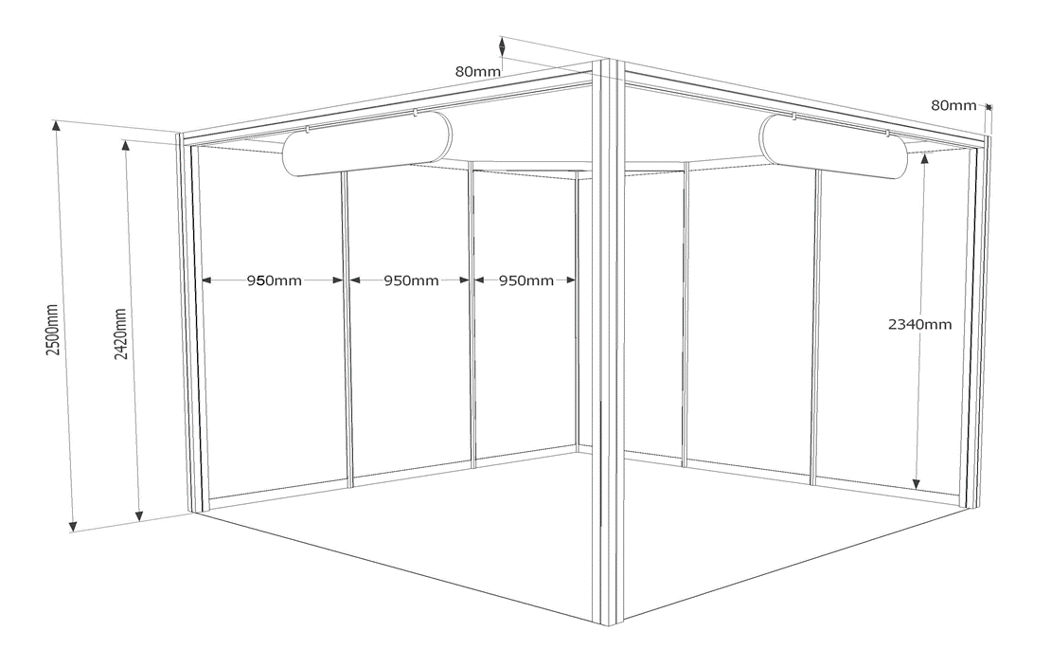

Permitted

The following items are permitted for use on the Foamex panels, but not on the framework:

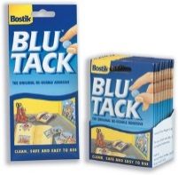

VELCRO

BLU TACK

Not Permitted

The following items are **NOT** permitted:

PINS



GLUE

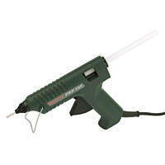

DOUBLE SIDED  
TAPES



NAILS



STAPLES

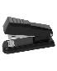

SCREWS

PAINTS





A-Z RULES AND REGULATIONS

Annoyance

The Exhibition Organisers reserve the right to stop any activity on the part of any Exhibitor that may cause annoyance to other exhibitors or visitors. Business must be conducted only from the Exhibitor’s own stand and under no circumstances may this be carried out from a gangway or elsewhere within the Exhibition.

Balloons and Bottled/Compressed Gas

The use of balloons within the Venue is strictly regulated. If you do wish to have helium balloons, should any escape to the roof, there could be a cost in retrieving the balloon. Most importantly, if you will be bringing a gas cylinder then you need to inform BCS/Health and Safety of this. You will not be able to keep the cylinder on your stand due to H&S regulations; instead, the Venue will store it suitably for you.

If you decide to go ahead with balloons then you will need to inform Carol MacInnes at [carol@onsitex.co.uk](mailto:carol@onsitex.co.uk) and Claire Cartwright at [exhibition@bcs.com](mailto:exhibition@bcs.com) in writing at least 28 days prior to the event (via Exhibitors Health and Safety Declaration and Exhibitor Risk Assessment Form).

Broadcast of Music

Persons requiring music to be broadcast, whether live, from tapes, discs on stands or other areas, are advised that they will require a licence for the performance of music from The Performing Rights Society Limited (PRS), which has rights under The Copyright Designs & Patents Act 1988. Any person wishing to have music broadcast must inform the Organisers. The exhibitor will be required to pay all fees due to The Performing Rights Society Limited (PRS) Copyright House, 29-33 Berners St, London W1T 3AB.

Children and Animals

Under no circumstances will children under 16 be allowed into the Exhibition Halls during the tenancy period. Animals are not allowed onsite. Guide and hearing dogs are permitted on request.

Conduct of Exhibitors/Contractor

Exhibitors **will not** be allowed to display exhibits in such a manner as to obstruct gangways or affect the displays of neighbouring exhibitors. Gangways must at all times be kept clear and free for passage. All emergency exits and access to service areas are to be kept clear at all times and must not be restricted or rendered unrecognisable. Public gangways shall remain the means of escape even during build up and breakdown periods. Any Exhibitor who continues to cause obstruction or nuisance after notice has been given will be liable to have their stand closed by the Exhibition Organisers at the Exhibitor’s expense and risk.

Dilapidation Charges

Please remember that you are responsible for making good any damage caused to the fabric of the exhibition buildings, by you, your agents or contractors. It is in your own interest to satisfy yourself as to the condition of your site before commencing the building (space only) or dressing (shell scheme) of your stand and again after its clearance. The organisers will pass to the exhibitor any charges for damage to the exhibition halls caused by exhibitors, staff or their contractors.

Environmental Policy

To view Manchester Central’s Sustainability Policy, please visit their website [here](https://www.manchestercentral.co.uk/sustainability-our-central-future).

Insurance

Exhibitors are reminded of the need to consult their insurance company or brokers to cover themselves fully against all risks at the Exhibition. The Exhibition Organisers can advise Exhibitors of suitable insurance brokers upon request. Particular attention is drawn to the need for the following:

**Abandonment Insurance**:As stated in the exhibition terms & conditions the Exhibition Organisers are not obliged to return any monies paid for space in the event of cancellation or restriction of the Exhibition.

**Stand, Fixtures and Similar Insurance***:* All risks on loss or damage to Exhibitor’s property, fixtures, fittings and all other property of a similar nature such as personal effects of directors, principals and employees whilst on the Premises and transit risks from the Exhibitor’s premises to the Exhibition and return.

**Public Liability Insurance**:Liability to the public may arise out of the Exhibitor’s/principal contractor’s activities and should be covered by insurance.

Exhibitors must not use, permit or bring into the Premises or any part thereof any act or thing which may render any extra or increased premium payable for any of the Exhibition Organisers and/or the exhibition area’s insurance policies, including but not limited to material damage, consequential loss or public liability insurance.

Liability

The Exhibition Organisers will endeavour to protect exhibition property while on display at the Exhibition. However, it must be clearly understood that the Management of the venue and the Exhibition Organisers cannot accept liability for any loss or damage sustained or occasioned from any cause whatsoever. Exhibitors will be responsible for all damage to property and for any loss or injury caused by them or their agents or employees and will indemnify the Exhibition Organisers against all claims and expenses arising there from.

In the event of it being necessary for any reason whatsoever for the Exhibition to be abandoned, postponed or altered in any way in whole or in part, or if the Exhibition Organisers find it necessary to change the dates of the Exhibition or vary the hours the Exhibition is open, the Exhibition Organisers shall not be liable for any expenditure, damage or loss incurred in connection with the Exhibition.

The Exhibition Organisers shall further not be liable for any loss that the Exhibitor or Exhibition Contractors may incur owing to the intervention of any authority which prevents or restricts the use of the Premises or any part thereof in any manner whatsoever.

Meeting Blackout Periods

There are strict rules regarding holding meetings during the BCS Annual Conference. Meetings are **NOT** to be scheduled during the opening times of the conference.

Microphones/Audio Visual Equipment

The use of microphones/audio visual equipment is permitted, but the volume must not be such as to cause annoyance to other Exhibitors. The Exhibition Organisers reserve the right to prohibit their use if in the Exhibition Organiser’s opinion this is the case.

Publicity Material

Any publicity material shall ONLY be displayed and/or given away from the Exhibitor’s own stand. Leaflets displayed at any other point throughout the Premises will be removed or destroyed by the Exhibition Organisers.

Projected images, however generated, may not play into gangways or onto other stands. An Exhibitor may not, except by express written permission of the Exhibition Organisers, display directly or indirectly, advertise or give credits to any products other than their own or their named principal’s.

The display of acknowledgement or credit indicating membership of organisations or trade associations is not allowed except by the express written permission of the Exhibition Organisers. The Exhibition Organisers reserve the right to have covered or removed from the Premises any product or sign violating this regulation.

Soft Breakdown in the Education Zone of Education Hall

The soft breakdown in the Education Zone ONLY will commence from 14:00. Exhibitors in the Exhibition Hall must refrain from packing away and remain on site until the Exhibition Hall closes at 16:00 hours on the 7th June 2023.

Special Risks e.g., Smoke, Lasers, Inflatables, Medical Lasers, Strobes

All special effects must be treated as special risks and are subject to strict controls in accordance with a risk assessment and the appropriate Venue requirements. Information can be obtained on these from the Health & Safety Contractor – [carol@onsitex.co.uk](mailto:carol@onsitex.co.uk). Any exhibitor demonstrating or using any Special Risk products must note and observe the following requirement:

Full details of equipment that will be used must be submitted to the Exhibition Organisers and Health and Safety via Exhibitors Health and Safety Declaration and Exhibitor Risk Assessment Form in the first instance. You will then be contacted further for specific requirements. Please be advised that all information is required to be submitted to the Venue no later than 28 days before tenancy, so prompt return of Form 2 is crucial if approval is to be granted pre tenancy. Failure to submit adequate details may result in the special effect being prohibited.

BUILD UP/BREAK DOWN RULES AND REGULATIONS

Important Information Regarding Stand Approvals

Exhibitors who have taken "Space Only" sites must supply, erect and decorate free standing 2.5m partitioning on the periphery of their sites where they adjoin another stand. If this partitioning wall is higher than 2.5 metres, the rear of the wall adjoining any neighbour must be dressed down in plain white to 2.5 metres. Any side or dividing wall on the aisle must not exceed 2.5m in height.

There is no limit on installation length on walls under 1.50m. For any wall alongside a gangway, the length of the wall may not exceed 50% of the total length, except where the wall does not face or obstruct another stand. The remainder of the wall may be permitted to be clear safety or tempered glass or a Perspex derivative, but only following approval from the organisers.

Stand plans showing the floor and elevation measurements must be sent to the Organiser and Health and Safety Contractor as per the Exhibitor Manual.

**Please note:** A “Space only” stand does not include walling, power, floor covering or furniture. Sufficient walling must be provided to ensure all cabling is concealed. For “Space only” stands with platforms, please ensure exposed corners are rounded/splayed where adjoining a gangway.

**All persons working within the Exhibition Hall during full CDM build up and break down timescales are required to complete appropriate site induction and** Manchester Central now requires that only regulatory yellow or orange hi-vis should be worn in the Halls during periods of Build Up or Breakdown of the exhibition**. Safety footwear is always advised but a strong soled shoe with ankle support can be worn at your own risk (Exhibitors only). This does not apply to periods of “soft build and soft breakdown” as identified within this Manual or to Contractors who are required to wear safety footwear during periods of build and breakdown.**

This is to assist in the safety of contractors, organisers and Manchester Central staff during what can potentially be a particularly hazardous environment. Please note that the Organisers will not have a supply of hi-vis vests. These can be purchased at the Venue’s concierge desk in the Central Foyer.

It is predicted that on the majority of occasions, exhibitors will not be required to wear a high visibility vest as by the time they are scheduled to have access to the hall, hazardous activity should be complete but they will be required to wear them during the breakdown if it is their intention or requirement to stay on site beyond the permitted 1-hour time slot allocated for “soft “breakdown at the close of the Exhibition on 7th June.

This is in addition to appropriate protective wear (for example hard hats, steel toe/appropriate footwear etc.). CDM (Construction, Design and Management) Regulations 2015 were implemented within the exhibition and conference sector on 6th April 2016. They do not replace any existing legislation but are intended to provide a framework to help you ensure that your stand is constructed safely and help you understand your obligations.

These documents should be viewed as a summary for meeting minimum requirements and should at all times be used in conjunction with the Health and Safety at Work Act 1974, HSE’s exhibition specific guidance on CDM2015 and also the HSE’s official L153 guidance on CDM.

Space Only Exhibitors

Please read and take note of these guidelines as they apply to you.

Shell Scheme Exhibitors:

These guidelines only apply to you if you intend to carry out any construction within your shell scheme stand (i.e., build within your shell scheme). Stand dressing, posters, placing display cases, freestanding furniture etc. do not constitute construction.

Understand your responsibilities:

a. Space only exhibition stands will be classed as sub CDM “sites”, within the overall CDM Site, (the Principal Contractor of which is the BCS) with a separate management hierarchy to that of the shell scheme, feature areas, flooring, logistics and other “main contractor” services procured and managed centrally by the exhibition organiser.

b. Under CDM, your role is defined as that of the Principal Designer and Principal Contractor of a sub CDM site.

c. Both of these roles require the Stand Builder to ensure that the CDM “Client” – i.e., the exhibitor – is aware of their own duties within CDM, which are effectively to provide resources to the project, appoint the other CDM roles, manage their coordination and ensure that these other organisations fulfil their duties such as producing a Construction Phase Plan, Risk Assessment, Method Statement, technical stand plans and Public Liability insurance.

d.  As well as educating the exhibitor, as a Principal Designer a Stand Builder will be responsible for controlling the pre-construction design and planning phase of the project, using exhibitor and venue provided information, coordinating in-house and external technical designers including a structural engineer where relevant, designing out fabrication and assembly risk before production starts and Principal Contractor liaison (if not taking this role on themselves).

e. As Principal Contractor, the Stand Builder will then manage and monitor the construction and de-rig safely, documenting their approach in a Construction Phase Plan, will coordinate and manage freelancers and subcontractors, undertake an induction talk and provide relevant health and safety information, instruction, training and supervision to all personnel, including emergency and first aid arrangements. Draft HSE guidance suggests that Stand Builders should undertake due diligence on their own suppliers and also on those suppliers appointed by a venue or an organiser. Please note that our appointed health and safety provider (Carol MacInnes OES Limited) - [carol@onsitex.co.uk](mailto:carol@onsitex.co.uk) will provide a Construction Phase Template (CPP) to assist if necessary and can be contacted pre tenancy and onsite if advice or assistance is required.

Welfare Arrangements

The majority of requirements required through CDM are already in place at most major UK Venues and this information will be detailed on the Site Rules & Information (Project Management Form) which will be provided to all space only contractors as part of the site induction process:

* Access to toilets, seating, drinking water and a retail food outlet or alternative source of food will be documented within this piece of information.

Over and above that, you should ensure that the Welfare of the team carrying out the construction is planned for. Think about:

* Working hours
* Equipment required

During the Hard Breakdown, regulatory yellow or orange hi-vis and appropriate footwear must be worn in accordance with mandatory CDM Regulations.

Please be advised that contractors at this Event must wear hi-vis vests and safety footwear where they are involved in manual handling and construction unless their own Event Risk Assessment indicates that other engineering controls have been introduced which only require “appropriate footwear” to be worn or if the contractor has a medical exemption letter from their GP confirming the wearing of safety footwear is detrimental to their foot health. In such circumstances, contractors will be required to complete a disclaimer on site confirming their own personal liability should an accident/injury occur as a direct consequence of not wearing ‘safety footwear’. Please be advised that requests for the non-wearing of safety footwear for no reason other than “they are not comfortable” will not be granted especially if their employing Company stipulates the wearing of safety footwear within their individual Risk Assessment.

Vehicles And Pedestrian Routes

It is difficult to completely separate vehicle and pedestrian routes during an event build-up and breakdown. However, there may be designated operational forklift lanes which will be in use at specific times and will be identified on site. It is imperative that all space only contractors working adjacent to the lanes ensure that their stand materials/equipment do not jeopardise or infringe upon clear movement in these areas.  Additionally, please be clear with any staff that you are bringing on site that care should be taken at all times.

If your teams are operating in loading areas they should be aware of the movement of traffic and should wear hi-visibility clothing as a minimum. Where you are able to drive a vehicle within the event perimeter your driver should be made aware that pedestrians have right of way AT ALL TIMES and there will be speed restrictions in place.

Whilst every endeavour is made to secure the halls during build-up and breakdown we would ask that all exhibitors are extremely vigilant whilst the access doors are open and always ensure that someone is on the stand at all times.

No goods should be left unattended at any time. Neither the Organisers nor Manchester Central can accept any responsibility for any loss or damage.

Build Information Space Only – Health and Safety

Free-build stands are allocated on a space only basis. This means that **no stand services are included (for example, walls, carpets, electrics). All stand services need to be ordered and paid for by the exhibitor.**

Please provide the details of your stand contractors to Carol MacInnes (ONSITE Exhibition Services Ltd) [carol@onsitex.co.uk](mailto:carol@onsitex.co.uk) and Claire Cartwright [exhibition@bcs.com](mailto:exhibition@bcs.com) on the form once provided. Detailed scale drawings, including plan views and elevations of all space only stands must be submitted, preferably electronically. Details of the materials used to construct the stand, a risk assessment (to include fire hazards), method statement, Construction Phase Plan (CPP) and proof of Public Liability Insurance (PLI) which must be in date for the duration of tenancy must also be submitted at this time. Additionally, please ensure that accessibility is considered when designing a stand (including the availability of a portable access ramp and appropriate signage for platforms under 100mm in height) and an integrated ramp when the stand platform is 100mm or greater. Please look at the latest edition of the eGuide when considering an integrated ramp as there are many requirements to ensure compliance. Platforms on stands adjoining a gangway should also be rounded or splayed in line with current eGuide recommendations and where the platform is adjacent to a gangway. Please liaise directly with Carol MacInnes (OES Limited) [carol@onsitex.co.uk](mailto:carol@onsitex.co.uk), our appointed Health and Safety Consultant, who will be happy to advise and assist with any health and safety queries in this regard.

Additionally, and in line with CDM Regulations, site induction for all contractors must take place prior to entry on site for both build and breakdown phases. Carol MacInnes (OES Limited), our onsite appointed Health and Safety Consultant, will provide site rules, project management information, a CPP template (if required) and induction paperwork pre tenancy. Please ensure you comply with all requirements.

Space only information (including principal stand contractor details) and on stand activities during the open period must be detailed on the Exhibitors Health and Safety Declaration and Exhibitor Risk Assessment Form.

Exhibitors Health and Safety Declaration and Exhibitor Risk Assessment Form

**Complex Structures**

A complex structure is any form of construction of any height which may require input from a structural engineer. Examples of complex structures are:

* Any structure, regardless of its height, which requires structural calculations
* Multi-storey stands
* Any part of a stand or exhibit which exceeds 4 metres in height
* Suspended structures (not including fabric banners) e.g., lighting rigs or bespoke timber suspended rigs
* Sound/lighting towers
* Temporary tiered seating
* Platforms and stages over 0.6m in height and all platforms and stages for public use (not including stand floor flats and platforms)
* Temporary demountable structures e.g., marquees.

**Please note** that should a stand be deemed complex, the services of an independent structural engineer will be required, the charge for which will be levied to the stand contractor direct. Please contact Carol Macinnes - [carol@onsitex.co.uk](mailto:carol@onsitex.co.uk) for any advice and assistance.

EXHIBITION TERMS AND CONDITIONS

**EXHIBITION TERMS AND CONDITIONS DEFINITIONS**

'Application Form' means the application form for making a Booking for the Event as completed by the Exhibitor and submitted to and accepted in writing by the Organiser; 'Exhibitor' means the party referred to as such in the Application Form and such expression includes the Exhibitor's employees and contractors; 'Event' means the event referred to in the Application Form; 'Exhibits' means all displays, brochures, leaflets, documents, promotional materials, computer and other equipment, banners, signs and other items that the Exhibitor brings to the Venue pursuant to the Contract; 'Charges' means the charges, excluding VAT thereon, payable by the Exhibitor to the Organiser in connection with the Booking as set out in the Application Form; 'Manual' means the Organiser's Event Information Pack to be provided to the Exhibitor prior to the Event and as the same may be updated or revised from time to time; 'Organiser' means British Cardiovascular Society and its successors and assigns; 'Terms and Conditions' means these terms and conditions; "Contract" means the contract between the Organiser and the Exhibitor for the Booking comprising the Application Form, the Manual and these Terms and Conditions; "Booking" means the reservation and use of allocated space for the Exhibits at the Event pursuant to the Contract; "Venue" means the Venue for the Event referred to in the Application Form subject to any change made thereto under the Contract.

**PROMOTION AND REPRESENTATIONS**

The Organiser shall organise and promote the Event in such manner as it considers appropriate. No representation or warranty is made by the Organiser as to the manner in which it will promote the Event or that any other exhibitor will attend the Event or that any number of attendees will attend the Event.

**DISPLAYS AND EXHIBITS**

The Contract provides the Exhibitor with a limited, non-exclusive licence to access and occupy the designated space allocated to it at the Venue for the Event and during the times provided for in the Manual. The Exhibitor shall only be entitled to display materials and items that comply with the Manual and acceptance by the Organiser of the Application Form shall not be taken to imply its acceptance of any proposed Exhibit. The Exhibitor must satisfy itself that all Exhibits comply with the Manual and undertakes not to display or bring into the Event any materials, documents or information that may be offensive in any way or defamatory or which may be dangerous or harmful including (but without limitation) explosives, detonating or fulminating compounds and any inflammable materials. The Organiser reserves the right to require the Exhibitor to remove any Exhibit at its sole discretion that it considers, in its absolute discretion, does not comply with the requirements of the Manual. Exhibits shall be installed at the Exhibitor's expense and the Exhibitor shall remain fully responsible for the Exhibits which, while at the Venue, shall be at the Exhibitor's risk.

**SERVICES AT THE VENUE**

The Organiser will use all reasonable endeavours to ensure the supply of the services provided to exhibitors at the Event as set out in the Manual but shall not incur any liability to the Exhibitor if any service fails or is not available for any reason outside of the Organiser's reasonable control. The Exhibitor agrees that the Organiser and/or the Venue operator and their contractors may at any time enter the Venue during or prior to the Event and execute works, repairs and for other purposes and no compensation will be payable to the Exhibitor for damage, loss or inconvenience so caused to any Exhibits or other property of the Exhibitor.

**ALTERATION TO ALLOCATED STAND**

The Organiser reserves the right, without being required to give notice to the Exhibitor, to alter at any time the layout of any Event floor plan or the position or specification, including its the size, shape or design, of any stand including the Exhibitor's stand provided that if the floor space allocated to the Exhibitor is reduced, the Charges shall be reduced proportionately to the amount of such reduction in space.

**ERECTION OF STANDS AND EXHIBITOR PROPERTY**

The Exhibitor acknowledges that the Organiser has appointed official stand contractors and, where directed by the Organiser, the Exhibitor must engage these contractors and at its cost for the construction of the Exhibitor's stand provided that the Exhibitor may be permitted to appoint its own contractor for the shell scheme and interior of its stand with the prior written consent of the Organiser. For Stand plans, showing the floor and elevation measurements and, for non-shell scheme stands, a dimensional drawing with full details of the Exhibitor's stand must be provided to the Organiser in the form and at the timings stated in the Manual. If the Booking is for "Space Only" the Exhibitor must, at its own cost, supply, erect and decorate acceptable freestanding partitioning on the periphery of their sites where they adjoin another stand in accordance with the applicable requirements of the Manual which must not exceed 2.50m in height. Stand plans, showing the floor and elevation measurements must be sent to the Organiser as provided for in per the Manual. The Exhibitor is responsible for any loss or damage to its property or that of its employees or contractors and for any injury, loss or damage to any persons or to their property caused by any act or omission or negligence of the Exhibitor or any of its employees or contractors and the Organiser accepts no responsibility for any such matter.

**RESTRICTIONS**

Banners may only be rigged above the space allocated to the Exhibitor save for sponsor banners that have been approved in writing by the Organiser and all banners must meet the applicable requirements of the Manual. Promotional items such as brochures, leaflets and other documents, promotional goods and merchandise and signs may only be placed by the Exhibitor within the space allocated to it on the final floor for the Event and are not permitted in any aisles, public areas or conference rooms at the Venue. The Exhibitor shall not promote, advertise, distribute or otherwise display information or invitations to seminars, meetings or events unless the Organiser has approved the seminar, meeting or event in writing. Filming is strictly prohibited during the Event.

**CHANGES TO THE EVENT**

The Organiser may change the venue, time and date of the Event at any time and for any reason up to six months before the start of the Event [in which case the Organiser shall notify the Exhibitor in writing of any such change and the Booking shall be deemed to relate to the re-scheduled Event]. The Organiser may change the venue, time and date of the Event at any time prior to the date of the Event if, for any reason outside of the Organiser's control, it is unable to hold the Event at the original venue, time or date [in which case the Organiser shall notify the Exhibitor in writing of any such change and the Booking shall be deemed to relate to the re-scheduled Event]. The Organiser shall have no liability to the Exhibitor under or in connection with the Contract, whether in contract, tort (including negligence), breach of statutory duty or otherwise, in the event that the Event does not occur on the agreed date or time or at the agreed location as a consequence of any reason outside of its control, including, but are not limited to, the outbreak of war, act of terrorism, civil riots, governmental or other obstacles for to the freedom of travel, union actions, natural disasters, fire, flooding and or any other circumstances that fall within the meaning of the above, save for the repayment of any Charges paid by the Exhibitor to the extent that it cancels the Booking in accordance with the preceding provisions of this clause.

**GENERAL LIMITATIONS ON ORGANISER'S LIABILITY**

The Organiser shall have no liability to the Exhibitor for any claim under or in connection with the Contract, whether in contract, tort (including negligence), breach of statutory duty or otherwise, for any loss of profits, loss of sales or business, loss of anticipated savings, loss of use or corruption of software, data or information, loss of goodwill or for any special, indirect or consequential loss or damage. The Organiser's liability for any and all claims under or in connection with the Booking and/or the Contract, whether in contract, tort (including negligence), breach of statutory duty or otherwise, shall not in any event exceed the sum of all Charges paid by the Exhibitor to the Organiser for the Booking. Nothing in the Contract shall exclude any liability of the Organiser for death or personal injury caused by the Organiser's negligence or arising from the Organiser's fraud or fraudulent misrepresentation.

**USE AND CANCELLATION OF SPACE**

The Exhibitor must occupy the space allotted to it one hour before the start time of the first day of the Event failing which the Exhibitor shall be deemed to have given notice to cancel the Booking on the basis that the full amount of the Charges shall be payable by the Exhibitor and accordingly no refund shall be made of any Charges paid and the Organiser may resell or reallocate such space for its own benefit. The Exhibitor may only cancel the Booking with the prior written consent of the Organiser which it may withhold in its absolute discretion. Any request for cancellation must be made in writing and submitted by registered post to the address of the Organiser (and marked for the attention of the relevant person) provided for in the Application Form and received by the Organiser at least three months prior to the first day of the Event. The Organiser shall be entitled to withhold its consent to a cancellation request for any reason including if it is not able to re-let the cancelled space in its entirety. If the Organiser consents to a cancellation request it shall be entitled to payment of and/or retain (i) 10% of the Charges if the cancellation is accepted more than twelve (12) months prior to the Event; or (ii) 50% of the Charges if the cancellation is accepted after that time and up to three (3) months prior to the Event.

**PAYMENT**

The Organiser shall invoice the Exhibitor for the Charges in accordance with the payment schedule referred to in the Application Form. The Exhibitor shall pay the Organiser's invoices within 30 days of the date of the invoice or, if later, by the due date for payment of the relevant invoiced amount in accordance with the payment schedule. All payments to be made by the Exhibitor under the Contract shall be made in full and in cleared funds to the bank account stated in the applicable invoice. All amounts payable by the Exhibitor under the Contract are exclusive of VAT which shall be invoiced by the Organiser and paid by the Exhibitor in addition to the Charges. If the Exhibitor fails to make any payment in accordance with the Contract by its due date then, without prejudice to the Organiser's other rights or remedies, the Exhibitor shall pay interest on the overdue amount at the rate of 8% per cent per annum above the base rate from time to time of NatWest Bank plc such interest to accrue on a daily basis from the due date of the payment until actual payment of the overdue amount, whether before or after judgment.

**TERMINATION**

In addition to any other rights and remedies the Organiser may have, the Organiser may terminate the Contract immediately upon written notice being given to the Exhibitor to its address stated in the Application Form if (i) the Exhibitor fails to pay any amount to the Organiser when due under the Contract; (ii) the Exhibitor commits a material breach of any of its obligations under the Contract or persistently breaches the terms of the Contract; or (iii) the Exhibitor goes into voluntary or involuntary liquidation, becomes insolvent, or enters into any compromise or arrangement with its creditors or has a receiver, administrator or administrative receiver appointed over the whole or any part of its business, assets or undertaking. In the event of termination of the Contract by the Organiser pursuant to this clause: (i) all sums payable by the Exhibitor to the Organiser shall become immediately due and payable on demand; (ii) the Exhibitor shall reimburse the Organiser for all costs and expenses (including legal and other professional costs and expense) that it suffers or incurs as a consequence of the event giving rise to such termination or from recovering payment from the Exhibitor of any amount due under the Contract; and (iii) the Organiser shall have the right to remove and dispose of any property of the Exhibitor that may be present at the Venue and remove and/or exclude the Exhibitor and its staff from attending the Event.

**INDEMNITY**

The Exhibitor is responsible for and shall fully indemnify the Organiser against all costs, claims, demands, proceedings and losses whatsoever made against or incurred by the Organiser as a result of the Exhibitor promoting, advertising or exhibiting any goods or services at the Event.

**ENTIRE AGREEMENT**

The Contract constitutes the entire agreement between the parties in relation to the provision of the Booking and supersedes and extinguishes all previous agreements, promises, assurances, warranties, representations and understandings between them, whether written or oral, relating to its subject matter. The Exhibitor agrees that it shall have no remedies in respect of any statement, representation, assurance or warranty (whether made innocently or negligently) made by or on behalf of the Organiser that is A0486.0005\14585889.2 A0486.0005\14585889.3 not set out in the Contract and that it shall have no claim for innocent or negligent misrepresentation or negligent misstatement based on any statement in the Contract.

**ASSIGNMENT**

The Exhibitor shall not be entitled to assign, sublet, share, or grant licences in respect of the whole or any part of the space allocated to it. The Organiser shall be entitled to assign its rights and obligations under the Contract subject only to giving written notice to the Exhibitor of any such assignment.

**APPLICATION OF TERMS**

These Terms and Conditions apply to the Contract to the exclusion of any other terms that the Exhibitor may seek to impose or incorporate, including on any booking form or purchase order or other document. All terms and conditions that may be implied by law or which are implied by trade, custom, practice or course of dealing are hereby excluded to the fullest extent permissible.

**GOVERNING LAW AND JURISDICTION**

The Contract is governed by and shall be construed in accordance with the laws of England and Wales and the English Courts shall have exclusive jurisdiction in respect of any dispute arising in connection with the Contract.

KEY CONTACTS

|  |  |
| --- | --- |
| British Cardiovascular Society  9 Fitzroy Square  London  W1T 5HW  General Enquiries: +44 (0)20 7 383 3887  Email: [exhibition@bcs.com](mailto:exhibition@bcs.com)  Website: www.britishcardiovascularsociety.org | Manchester Central  (Exhibition and Conference Centre)  Windmill Street  Manchester  M2 3GX  Tel: +44 (0)161 827 7657  Website: [www.manchestercentral.co.uk](http://www.manchestercentral.co.uk) |
| Knight Rigging Services Ltd  Unit 5  Aldon Road  Poulton-le-Fylde  Lancashire, FY6 8JL  Tel: +44 (0)1253 894 688  Email: [MCCC@knightrigging.co.uk](mailto:MCCC@knightrigging.co.uk) | Full Circle Events & Exhibitions Ltd  Engels House  Victoria Mills, Weaste Trading Estate  Liverpool Street  Salford  M5 5HD  Tel: +44 (0)161 393 3949  Email: exhibitors@exhibitconnect.co.uk |
| Sterling Event Group  Tel: +44 (0) [**161 436 4444**](tel:+44%20(0)161%20436%204444)  Email: [info@sterlingeventgroup.co.uk](mailto:info@sterlingeventgroup.co.uk) | Onsite Exhibition Services Ltd  (Health & Safety)  Tel: +44 (0)7974 223 670  Email: [carol@onsitex.co.uk](mailto:carol@onsitex.co.uk) |
| National Car Parks  NML House  61 High Street  Manchester  M4 1AZ  Email: [ManchesterCentralVoucherapplication@ncp.co.uk](mailto:ManchesterCentralVoucherapplication@ncp.co.uk) | Manchester Central  (Waste and Water)  Windmill Street  Manchester  M2 3GX  Tel: +44 (0) 161 827 8746  Email: [tempservices@manchestercentral.co.uk](mailto:tempservices@manchestercentral.co.uk) |
| GES Logistics  Unit 13  Exhibition Way  NEC  Birmingham  B40 1PA  Tel: +44 (0)121 782 4433  Email: [event.logistics@ges.com](mailto:event.logistics@ges.com) |  |

GETTING TO MANCHESTER

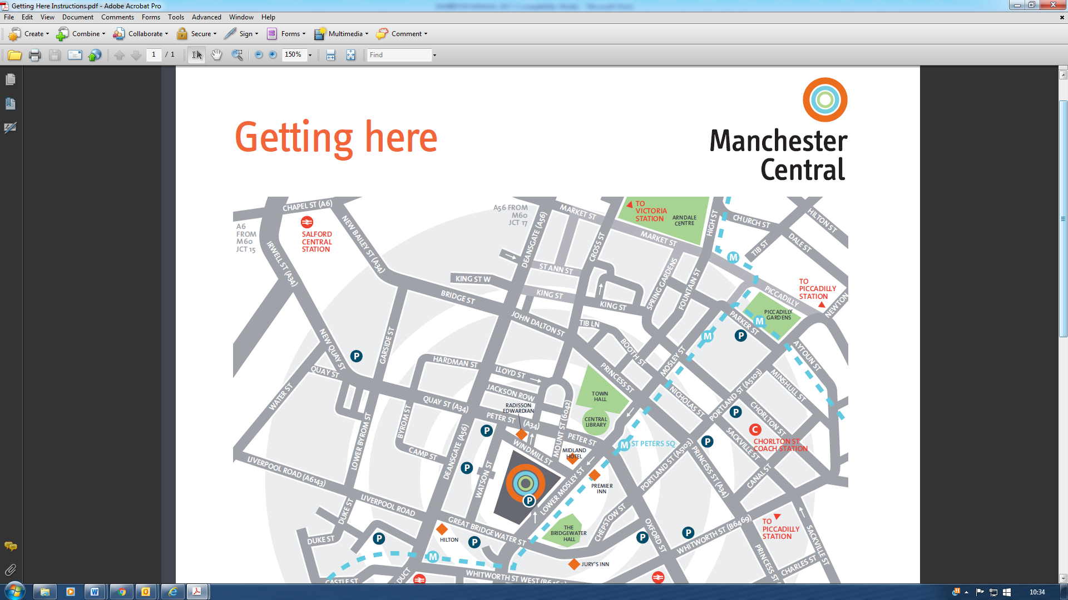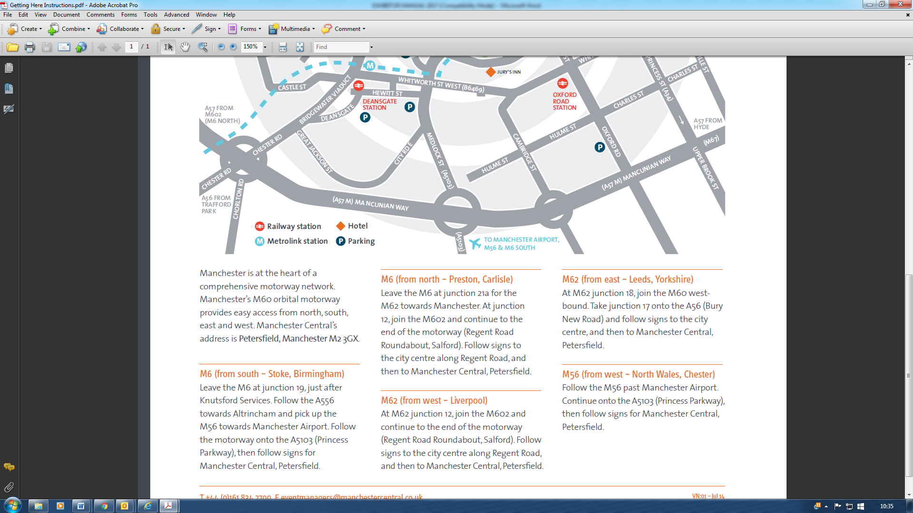

DELIVERY ACCESS

